Hebog Environmental Ltd.
ENVIRONMENTAL POLICY STATEMENT

Hebog Environmental, established in 1998, is an independent marine science company with its own laboratory facilities in Bangor, North Wales. The Company’s core business is in the collection and identification of marine and estuarine benthic macrofauna, and in the interpretation of ecological data derived from these activities. Hebog are committed to maintain their position as the foremost provider of these services in the North West area.
Hebog Environmental is committed to protection of the environment, including pollution prevention and a commitment to continual improvement of environmental management and performance.
It is the ultimate responsibility of the Senior Management to ensure that the Environmental Management System is fully implemented, documented and maintained to ensure and to aid our commitment to the prevention of pollution. We are committed to the continual improvement and management of the system and committed to compliance with law, regulation and Green Dragon Environmental Standard Level 2.

Through monitoring of our main environmental impacts, our targets for the period 2026/27 are:
- Waste management – Recycle all paper and reduce the volume of paper used in the laboratory.
- Energy consumption – Reduce energy consumption by an additional 5% of the EMS year 5 target.
- Water use – Reduce water consumption where possible.
- Purchase supplies from environmentally responsible companies where possible.
- Recycling – return used plastic buckets to our clients for re-use.
- Try to reduce miscellaneous waste where possible

The organisation will encourage best environmental practices and review our activities and operations to identify environmental impacts and prioritise action to reduce and minimise them. To this end meaningful targets will be set annually to reduce our environmental impact.

We aim to reduce our environmental impact by carrying out the following practices:
- Monitoring our waste production.
- Monitoring energy consumption.
- Recycling where possible.
- Making staff aware of company policy and their environmental responsibility.
- Replacing old equipment with more energy efficient equivalents.

Following the list above we intend to fully comply with all legal and other requirements to which we subscribe that relate to our environmental aspects.

We aim to provide the framework for setting the environmental objectives and targets as follows:
- By consultation with appropriate external agencies, both locally and nationally.
- Periodically checking that our compliance is up to date by correspondence with those appropriate external agencies and by checking documentation.
- By consulting with our customers at contract, management and service levels.
- By discussion at Management Review level and Environmental meetings.

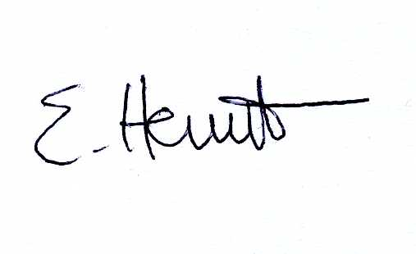
Managing Director

Dated: 02/03/2026

